Reverend Anthony Johnson receives HANDS Community Leadership Award

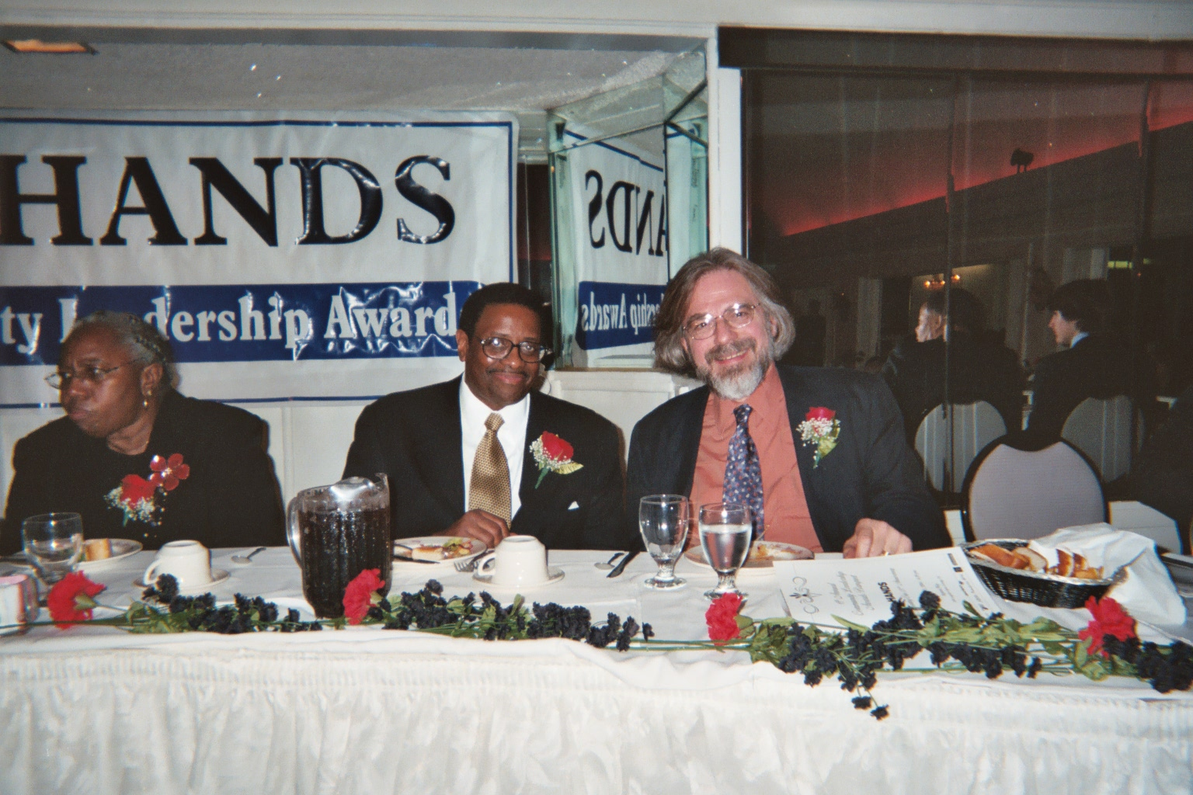

At the Sixth Annual COMMUNITY LEADERSHIP AWARDS BANQUET of HANDS, Inc.,
on November 12, 2004, Reverend Anthony Johnson was honored as “A dedicated leader
who uplifts and empowers the City of Orange and the neighboring communities.”

